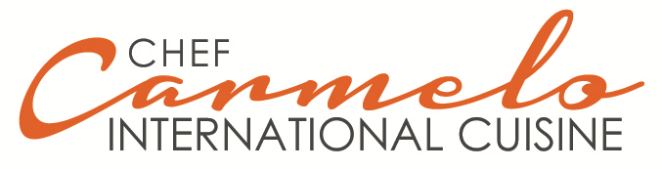

List of Appetizers by the Chef Carmelo.
Trays of 100 und. (They can be 25 as min).
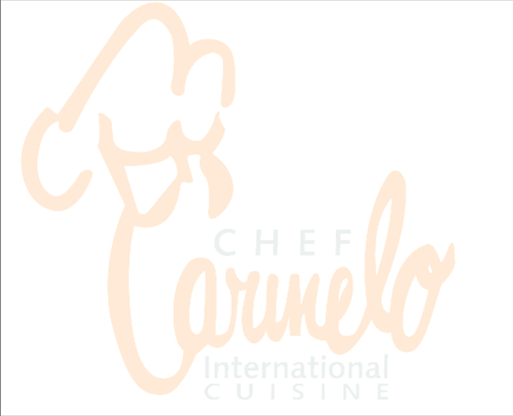
- Shrimp and Salmon Mousse 2.75
- Babaganoush (Dip of Eggplants)X lb. 7.00
- Samosas (Hindi) 1.25
- Hummus (Chickpea Dip) x lb. 7,00
- Hammbra (Red Pepper and Paprika Dip) x lb. 8,50
- Mini quiche Lorraine 1,25
- Dolmathes (Stuffed Vine Leaves)X lb. 9,00
- Tartlets stuffed with Roquefort mousse, pears and walnuts 2,50
- Shrimp Timothy and Garlic 1.75
- Oysters in Asparagus Sauce 2.75
- Ham and cheese rolls 1,25
- Meat balls with pomodoro sauce 0,85
- Serrano ham roll 1.75
- Salmon and Cucumber Canapes 1,65
- Stuffed Endives of Salmon 2.25
- Soufflé of Crab with Mushrooms 2.25
- Endives with Cream Roquefort 2.25
- Skewers of Beef tendorloin and Fungi in Butter Sauce with Herbs 2.50
- Currants with Smoked Salmon 1.95
- Thai Tofu Curry 0.95
- Canapés with Prawns and Caviar 2.95
- Croquetas (Varies) 1,00
- Duck Pate with Red Wine Gelatin x lb. 15,00
- Tartaletas de Vegetales 0,95
- Artichoke Heart Antipasto with Garlic Vinaigrette and Smoked Red Paprika 9.00 x lb

- Chicken Yakitory 1.25
- Brie cheese canapes with candied figs 1.95
- Chicken cubes in sesame with mango chutney 1.75
- Natural lobster canapes with radish cream 3.50
- Mini Wraps (Varies) 1.50
- Corn tortillas with guacamole 0,95
- Smoked Grouper with Black Bread and Tartar 1.50
- Lobster Canapes to Thermidor 2.95
- Steak Tártare of Mero fish 1.50
- Dice of mero fish to the Dijon 1,25
- Steak Tártare of beef tendorloin 1,85
- Crab Croquettes 1,50
- Corvina Ceviche x lb. 25.00
- Mini Skewer of Seafood 1,50
- Carpaccio canapés of beef tendorloin 1,85
- Mini Fillet Skewer 0,95
- Smoked Mousse Canapes 1,85
- Mini-crêpes de Mariscos 1,50
- Turkey Canapes with Cranberry 1.95
- Mini-crêpes of corn 0.85
- Canapés de Capresa 0,85
- Mini Onion crêpes 0,85
- Roast Beef with Guasacaca 1.50
- Mini-crêpes of cheese 0,85
- Quail Eggs with Pink Sauce 0.95
- Pizzas Miniatures 0.95
- Pork Shanks with Apple Sauce 1.75
- Mushrooms with Ajillo x lb. 8.50
- Taquitos of Ham with Pineapple 0.95
- Spanish Tortilla 0,95
- Celery sticks with Roquefort dip 1,00
- Lumpias Chinese 1,25
- Dip Assorted x lb. 5.00
- Dates to Temptation 1.50
- Assorted cheeses tray 35.00
- Octopus a la Gallega x lb. 10.75
- Eggplant vinaigrette x lb 6.50
- Chicken Croquettes 1.25
- Profiteroles with guacamole 1.00
- Cachapitas (corn pancakes) with white cheese 1,25
- Crab Tongs with American Sauce 1.95
- Prunes with Bacon 1.25
- Salmon Roasted 2.25
- Chicken Balls with Sauce 1.25
- Shrimp Ceviche x lb. 30.00
- Farmer Fondue x lb. 20.00
- Serrano ham with melon 1.75
- Tartlets of scallops gratinated 2.50
- Mini Sweets Assorted
- Dumplings (Asian Asparagus in Gral.) 1,25
- Tuna Tataky 1,75
- Prosciutto with Cream Cheese and Pears 1,75
- Oysters Roquefeller 2,25
- Herbal Cheese Canape 0,95
- Chicken cubes with honey 1.65
- Nuts Cheese Canapé 1.25
- Nibs of Cheddar Cheese with Almonds 1.25
- Canapé Pepper Cheese 0.95
- Phyllo Dumplings with Spinach and Feta 1.75
- Canapé of Cheese of Dry Tomatoes and Pesto 1,50
- Mini Filet Mignon of beef tendorloin 1,75
- Mango Chutney Cheese Canape 1,50
- Mini Filet Chicken Mignon 1,65
- Tabboule (Arabic) Casserole 4.95 x lb
- Brussels Sprouts with Dutch Sauce 0.95
- Hummus Cheese Canape 0.95
- Parmesan Cheese Dumplings 0,95
- Babaganush Cheese Canape 0.95
- Duck magret skewer with shiitake mushrooms with teriyaki sauce 2.75
- Hammbra Cheese Canape 0.95
- Asian Cheese Canape 0.95
- Prawns in Basil Tempura 1.95
- Peach and Nougat Cheese Canapes 1,75
- Little Stomp-style Skewers of Strogonoff 1.95
- Ricotta cheese balls with fine herbs and cheddar cheese 1.25
- Shrimp skewer with paprika 1,75
- Cherry Tomato Stuffed with Goat Cheese with Thin Herbs 1.50
- Chicken Skewer Curry with Pineapple Roasted 1.50
- Mini Crêpes of Goat Cheese with fine herbs 1.50
- Skewer of Octopus and Papitas al Mojo 1,75
- Mini Cream Cheese and Chives Crêpes 1,50
- Gougéres de Roquefort and Pera 1,75
- Gougéres of Cheese of Goat and Pimentón Morrón 1,75
- Pineapple and chicken sandwiches 1.50
- Caviar Canapes 1,75
- Prawns with Creamy Curry 1.75
- Lobster Canapes (According to Season) 2.95
- Puff Pastry Pâté with Peasant Pâté and Red Wine Molasses 2.25
- Kofta Spicy with syrup dip of roses (finger of Hindu ground beef) 1.95
- Salmon and Apple Skewers as a Ceviche 2.25
- Top of bulbs of onions candied with paté Maison 2,75
- Pork Loin Puffs with Peanut Sauce (Thai) 1.25
- Maize Blinis with Ham Prosciutto 1,95
- Thai small bags stuffed (Arruchaditos) (Thai) 1,25
- Bruscheta de Serrano Ham and Sweet Pimenton 1,75
- Chicken satay (Thai) 1,25
- Grissini with Ham Serrano 1.75
- Salmon and Curry tartare canapes 2,50
- Tequeños 2,00
- Beef carpaccio with onion confit to Porto 2,25
- Terrine (various) x lb. 5.75
- Courgettes Stuffed with Prawns 2.65
- Voulevant stuffed with asparagus mousse 2.25
- Paté Maison x lb. 8.75
- Tartlets of angulas 2,95
- Salmon and Caviar pastries 3.95
- Tartlets with tartare of vegetables 0,95
- Pickled x lb. 6.95
- Mini arepitas 0,95
- Sushi Rolls Assorted 1.25
- Mini Empanaditas 0.95
- Blinis with Caviar 3.75
- Foie Gras Mousse 4.25
- Cheese Fritters 1.65
- Tartlets of celery and apple 1.25
- Grilled aubergine canapes with camembert cheese 1,25
- Buttons of mushrooms stuffed with cream of shrimp and prosciutto 1.95
- Fingers of fish with sauce tartar 0,95
- Tartlets with Russian salad 0.95
- Top of salmon and asparagus 2.75
- Roast Beef canape on green mustard 1,75
- Pork tenderloin with caramelized apples 1,75

